Machine Learning Foundations
Professor. Prashanth L A
Department of Computer Science & Engineering
Indian Institute of Technology, Madras
Eigenvalues and Eigenvectors
So, welcome to yet another lecture of machine learning foundations course, we are in week 4, and this is the second lecture and we will begin the discussion with some core linear algebra concepts here, in particular the most important concept that is eigenvalue and also something associated with an eigenvalue, which is eigenvector.
So, we will understand eigenvalues and eigenvectors for a given matrix, we will first in this course start with a brief motivation on the which illustrate the need for this concept of eigenvalues and eigenvectors. And then we will define concretely what for a given matrix what is an eigenvalue and what is an eigenvector. And then we look at a procedure to calculate these for a given matrix, calculate all eigenvalues and eigenvectors in this lecture.
(Refer Slide Time: 1:10)
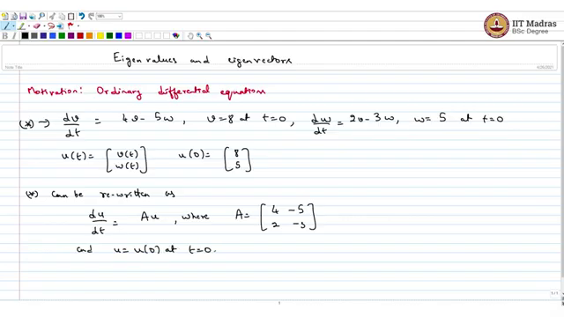
We will start the discussion with eigenvalues and eigenvectors, and then cover a lot of topics which build on this, which is looking at real symmetric matrices and trying to look at eigenvalue decomposition and, and also singular value decomposition, which is a further step from there. And finally, we end with principal component analysis, that is the plan for this module, which is linear algebra module 3. We will start more basic will try to understand what eigenvalues and eigenvectors.
And before I do that I will start with the motivation, why do we care about eigenvalues and eigenvectors. The motivation I am going to use is ordinary differential equations. So, imagine you have an equation like this, dv/dt= 4v-5w with the initial condition v = 8 at t = 0. And add in the other equation the second equation is du/dt =2v - 3w and with the following initial condition, w = 5 at t = 0.
So, if I use in compact notation imagine v and w I think v and w is better, this is w and so u is in compact notation say v and w it is a vector parameter two dimensional and u(0) is just whatever v(0), v(0) is 8 and 5. Now, given this I can write this as equation star let us, let me call this equation star, so star can be rewritten as du/ dt = Au, where A is the matrix of coefficient say$\left[\begin{matrix}4 & -5 \\ 2 & -3\end{matrix}\right]$ and u=u(0) at t = 0, that is the initial condition.
(Refer Slide Time: 4:02)
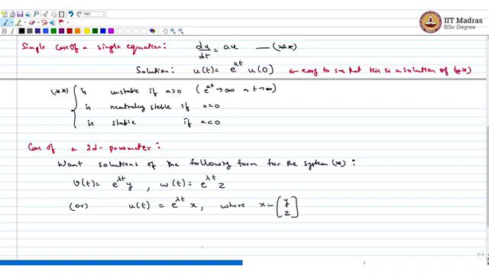
Now, you want to solve an ordinary differential equation like this and the solution of such equations leads naturally to eigenvalues and eigenvectors. And we have look at a very simple case consider a very simple case, simple case you just have one equation simple case of a single equation. So, I just have du/dt = au and a solution would be u(t) = e^{at} × u (0).
So, we can substitute this solution and see that, it satisfies, so let me call this au equation as double star yeah, it is easy to check easy to see that and this solution, this is, this is a solution of double star equation. Now, one is really concerned with stability this is beyond the topic of this course, but usually one cares about stability notions of this. So, star is unstable if a is greater than 0, simply because e^{at} goes to infinity, with t.
Now, star is it is called neutrally stable, this is not really needed for this course, but I am just and the third case is stable, this is the most interesting case if a < 0, because the solution it goes to a constant yeah, because e^{at} becomes yeah constant in that. Now, let us look at the case of a 2d parameter, so if I want to figure out a solution if I want solutions of this form, one solutions of this form which is say v(t) = say e^{λt} y and say w(t) of the following form for the system star, which I outlined above, or if I write it in the form of the vector parameter, I want this to be e^{- λ t}x, where x is just y and z.
(Refer Slide Time: 7:37)
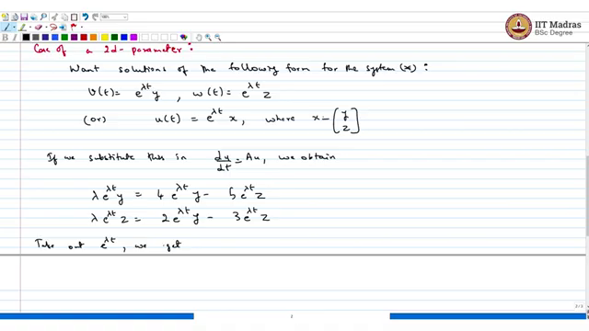
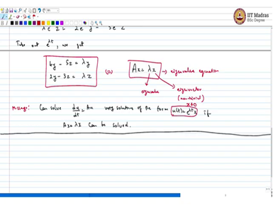
Now, if we substitute thus du/dt = Au we obtain, we get you just substitute in the two equations that I had before which is so λ e^{λ t} y = 4 e ^{λ t} y + 5 e ^{λ t} z, and λ e^{λ t} z = 2 e ^{λ t} y - 3e ^{λ t} z. The two equations that I had in v and w. Now, if you take out e^{λt}, we get, we get the very important equation that is.
Now, this equation is the same as Ax = λ x and this is the eigenvalue equation, I mean solving a linear system in an ordinary differential equation context comes down to solving an eigenvalue equation, here λ is the eigenvalue and we want an eigenvector, which is non trivial. So, it is a non-trivial, so it should not be 0.
So, the message is I can solve du /dt = Au using solutions of the form from whatever I had here u(t) = e ^{λt} x, if Ax = λ x can be solved. So, that is really the message and this leads naturally to the definition of eigenvalues and eigenvectors.
So, to summarize I can solve solution of a linear systems of ordinary, ordinary differential equations is really tied to solving an eigenvalue equation and if I can solve this then I can find a solution of the form that I have here yeah, which is here I can solve an equation with the solution of this form I can solve an ODE a with a solution of this form if I can solve Ax = λ x to obtain a non-trivial x.
(Refer Slide Time: 11:03)
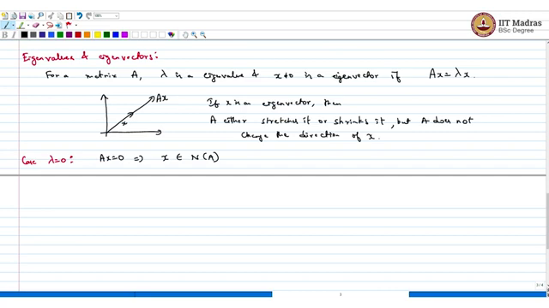
So, that leads to eigenvalues and eigenvectors definition, for a matrix A λ is an eigenvalue and x is an eigenvector, if Ax = λx. So, this is the eigen equation. So, geometrically if x is here, so if x is an eigenvector, then x is an eigenvector, then A either stretches it, or shrinks it. But A does not change the direction of x. So, that is eigenvalue and eigenvector definition.
We can look at I mean a special case, now if you take the case λ = 0 then Ax = 0 implies where does x reside, x belongs to the null space of A. So, that is the simplest example that you could think of.
(Refer Slide Time: 13:05)
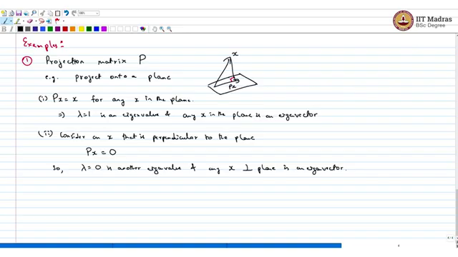
Now, we will look at a few more examples and directly just by eyeballing you can calculate the eigenvalues and eigenvectors, I mean at least the eigenvalues. So, the first example here is a matrix, projection matrix is something that we saw in the previous module, let us call this P for example project onto a plane, imagine you project onto a plane. So, take any vector x and then P_{x} will be here, it is a right angle.
Now, for this I would recommend you pause the video and think about the eigenvalues of this matrix and even the eigenvectors, strongly encourage to understand what are the possible eigenvalues and eigenvectors of this projection matrix, in this very simplest case think of projection onto on plane, which is illustrated here, I am going to go on and give out the answers.
So, you can see that P_{x} = x for any x in the plane, that makes implies λ = 1 is an eigenvalue and any x in the plane is an eigenvector. Now, what about that would be the first one, what about the second one is there another eigenvalue, the answer is yes consider an x that is, let me just write this as.
So, this is x is fine, x that is perpendicular to the plane, then what would happen to P_{x}? If x is already perpendicular to the plane, the only projection is 0. So, λ = 0 is another eigenvalue and any x perpendicular to the plane is an eigenvector. So, that is the first example.
(Refer Slide Time: 16:25)
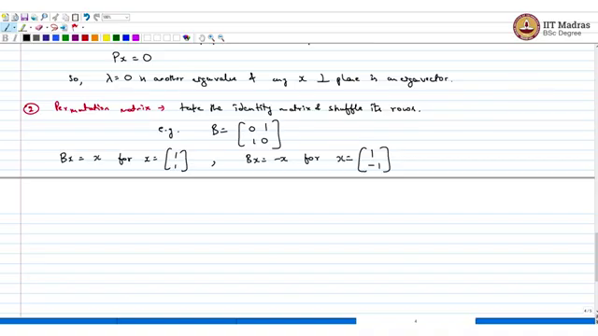
Let us look at another example, this is permutation matrix, a permutation matrix is by definition it is so what you do is, take the identity matrix and shuffle its rows, for example $\left[\begin{matrix}0 & 1 \\ 1 & 0\end{matrix}\right]$ this is a permutation matrix. Now, I can pause this video and try to figure the eigenvalue and eigenvectors of this, I am going to give out one example.
So, Bx = x try to find an x as that Bx = x, answer is x is [1, 1] ^{T,} the second is Bx = - x for what, can pause and try to figure this I have given you the eigenvalue already, the answer is x =
[ 1, - 1] ^{T.} So, by just these are very simple matrices, so you can just eyeball and find the eigenvalues and guess the eigenvectors.
(Refer Slide Time: 18:13)
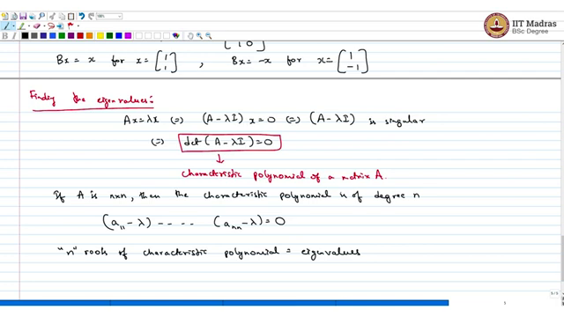
I mean but, there is a more systematic procedure to doing this finding the eigenvalues and the procedure to adopt for this is the following. So, let start with the eigen equation, so you have Ax = λ x which is equal to (A - λ I) x = 0, which is equivalent to saying (A - λI) is singular, which finally leads to determinant of (A - λ I) = 0. And this particular equation, when you write down this is called a characteristic polynomial of a matrix A.
Now, if A is n× n then, then the characteristic polynomial is of degree n, and I can write it as some {(a₁₁ – λ),…….. (a_{nn} – λ)}= 0, that would be how the characteristic polynomial. The n roots of characteristic polynomial, roots of this equation are the eigenvalues, so that is how you find.
(Refer Slide Time: 20:18)
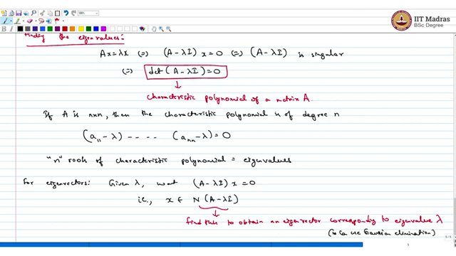
Now, that answers one part of the problem, how do you find the eigenvector, we saw that you know you are trying to find x such that (A- λ I) = x. So, for eigenvectors want, so if you are given Aλ, given λ want (A – λI) x = 0 that is x belongs to the null space of (A- λI). So, find this to obtain an eigenvector corresponding to eigenvalue λ. So, that is really the scheme and so can use Gaussian elimination, you can use gaussian elimination to solve A - λ x = 0.
(Refer Slide Time: 21:56)
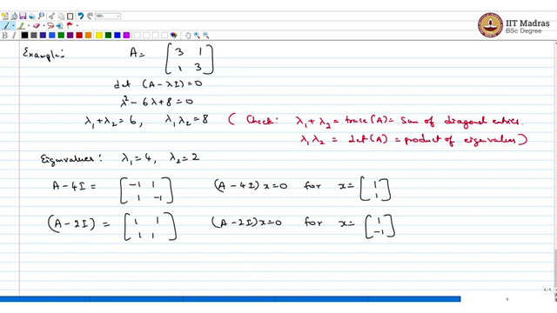
So, let us do an example, so suppose A is$\left[\begin{matrix}3 & 1 \\ 1 & 3\end{matrix}\right]$ so I would recommend pause the video calculate the eigenvalues, eigenvectors and then check the lecture to see if you have done the right thing. So, if I do determinant of (A - λI = 0), then that is λ² - 6 λ + 8 = 0, which is saying λ₁ + λ₂ = 6, λ₁ λ₂ = 8, you can verify check λ₁ + λ ₂, this is called the trace.
Trace of A is equal to sum of diagonal entries, this row in general and λ₁ λ₂ is the determinant of A, something you can check. So, 3 + 3 is the diagonal sum, that is the same as the sum of to eigenvalues and so on. Anyway, so the eigenvalues are for this, so the eigenvalues are λ₁ = 4, λ₂ = 2.
Now, I need to find the eigenvectors so I will look at (A - 4I), and that turns out to be subtracting 4 from the diagonal and that would be$\left[\begin{matrix}-1 & 1 \\ 1 & -1\end{matrix}\right]$ and so if we want to multiply this with a vector, such that this leads to 0. So, (A - 4 I) x, I want this to be 0 and that you can just see that x = [1,1]^{T} satisfies, when if x = [1,1]^{T} satisfies obviously x = [2, 2]^{T} satisfies and so on.
Now, for the other eigenvector (A - 2I) is $\left[\begin{matrix}1 & 1 \\ 1 & 1\end{matrix}\right]$ So, all I have to do is (A - 2I)x = 0 for x =[ 1,- 1]^{T}. So, that was a simple example, where the eigenvectors could be easily formed.
(Refer Slide Time: 25:00)
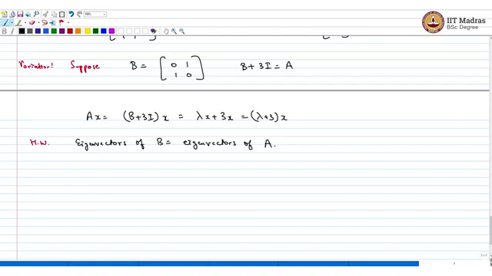
Anyway, here is variation, here is a variation of this matrix, suppose I make up a matrix that is very closely related to A. So, say B= $\left[\begin{matrix}0 & 1 \\ 1 & 0\end{matrix}\right]$ then how is this related to a (B + 3I) = A. Now, Ax= (B + 3I)x = λx + 3x = (λ + 3)x. Now, here is something I leave it as a homework, think about this Eigen vectors of B = eigenvectors of A. Try to think about try to argue why this is the case.
(Refer Slide Time: 26:17)
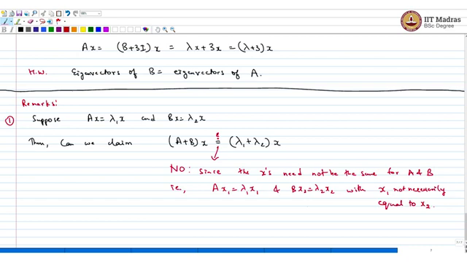
So, end with a few remarks one has to be careful while making these arguments. So, suppose I have two matrices, suppose Ax = λ₁ x and Bx = λ₂ x, then can we claim (A + B)x = (λ₁ + λ₂ )x. So, pause and think about this, can I claim that if A has eigenvalue λ₁ and B has eigenvalue λ₂. Can I really claim A + B has eigenvalue λ₁ + λ₂ with x as the eigenvector?
The answer unfortunately is no, since the x' is need not be the same for A and B, that is you have Ax₁ = λ₁ x₁ and Bx₂ = λ₂ x₂ with x₁ not necessarily equal to x₂. In fact, that we will see later this, thus this is the fact that would in the discussion towards the end of the discussion about eigenvalue decomposition, which is following soon.
(Refer Slide Time: 28:11)
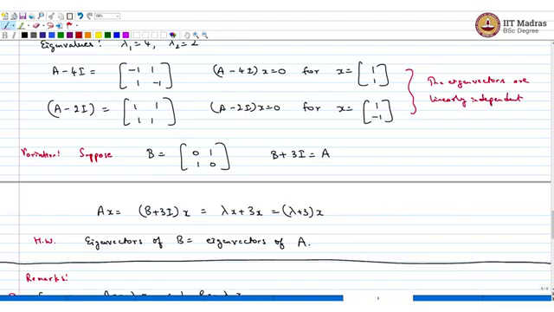
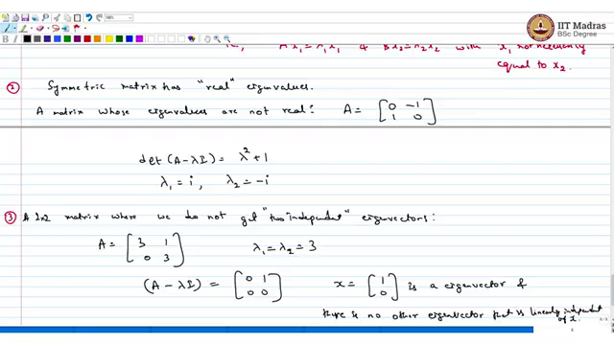
Is if you have a symmetric matrix, if you have a symmetric matrix then has real eigenvalues. Now, to appreciate this fact you should really see a matrix for which the eigenvalues are not real. And now a matrix whose eigenvalues are not real here is that matrix. So, pause again think about such a matrix, I am going to give out the solution there are many such examples, so the simplest is this.
And now what is determinant of (A - λ I) is λ² + 1, so, so the so eigenvalues are i and - i. So, the eigenvalues are imaginary, also in the previous example if you looked at the earlier example, we got two eigenvectors here and these were the Eigen vectors here are linearly independent. Now, this also may not always happen, so I will give you an example for such a matrix.
So, a matrix where we do not, do not get independent eigenvectors, we get two independent eigenvectors. So, let us take this matrix $\left[\begin{matrix}3 & 1 \\ 0 & 3\end{matrix}\right]$ you can see that I mean it is easy to see that λ₁ = λ₂ = 3. Now, what is (A – λI), which is $\left[\begin{matrix}0 & 1 \\ 0 & 0\end{matrix}\right]$so the only possible eigenvector which is non trivial x is [1, 0]^{T} is the not get two independent eigenvectors, or 2×2 matrix is a eigenvector and there is no other eigenvector that is linearly independent of x.
A quick summary before we end this lecture. So, in this lecture we looked at the motivation for using eigenvalues and eigenvectors, but in particular the idea is eigenvalues and eigenvectors help us understand the solutions to ordinary differential equations.
We saw a concrete example and then after defining eigenvalues and eigenvectors we saw that calculating eigenvalues amounts to solving this you know solving an equation which is called the characteristic polynomial, which comes as a result of calculating the determinant of a matrix given a matrix A, you solve (A – λI), the determinant of that equal to 0, and that is the characteristic equation. And we also understood what is the trace of a matrix and also the determinant of a matrix in relation to the eigenvalues.
Now, in the follow-up lectures, in the next lecture we will be looking at how, how many eigenvectors independent eigen vectors, I can get for a matrix, if I have enough eigenvectors can I diagonalize the matrix. So, this notion of diagonalization is highly related, strongly related to how many linearly independent eigenvectors I can get for that matrix. If I get n f, which is the here n f is the number of columns of that matrix. So, if A is encores in matrix and if I get n linear independent eigenvectors, then a is diagonalizable. So, this is an important idea that will come up in the next lecture.

